WHAT IS A FATBERG?
We are going to watch a video where they explain what a fatberg is.
Before watching the video
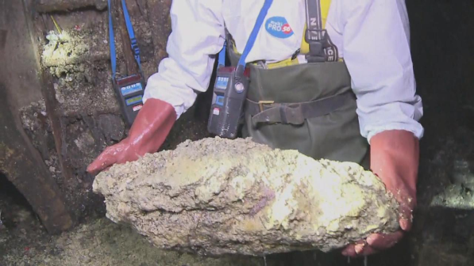
Speaking activity
-Have you ever heard about a “fatberg”?
- The word fatberg is made from fat +‎ berg,
modelled on iceberg.
-Look at the photo. Guess what a fatberg is.

Vocabulary activity
-This is a definition of a fatberg. Do you understand?
“-A fatberg is a solidified lump of fat, wet wipes, nappies and similar items found in sewers”
-These are words used in the video about a fatberg. Write each word beside its definition. How do you say it in your language?
-Fat -Garbage -Sewers -Wet Wipes -Diaper (Nappy)
-To Dump -To Pour - To Flush -To Clog
- Underground tubes for dirty water in towns
- A substance with oil
- Rubbish
- To put a liquid somewhere
- To throw something into the rubbish
- To throw something in the toilet
- To get blocked
- It’s something you put around a baby’s bottom
- It’s like a wet tissue

While watching the video
-We’ll watch the video twice.
-The second time we’ll stop the video whenever we can hear a word from the vocabulary list.
-Do you recognize the word? How did the speaker use it? Try to repeat the sentence that the speaker said.

After watching the video
Speaking activity
Talk to your partner:
-Try to explain what a fatberg is using the vocabulary from the list.
-Did you know about the problems caused by fatbergs?
-What can people do to avoid the problems caused by fatbergs?

